# Project Report

**1.INTRODUCTION**

**1.1 overview**

"Welcome to Riya Boutique Studio, where fashion and style find their perfect blend in every stitch. Located in the heart of Kundrathur, our clothing store is a haven for those who seek quality, diversity, and an unmatched shopping experience.

As you step through our doors, you'll be welcomed into a world of choice and inspiration. Our clothing store is a meticulously curated collection of garments and accessories, designed to cater to the tastes of all individuals. From timeless essentials to the latest trends, our selection embodies a celebration of individuality and self-expression.

The moment you enter, you'll be enveloped in an inviting atmosphere that's been thoughtfully crafted for your comfort. Our friendly and knowledgeable staff are always on hand to assist you in finding the perfect outfit, whether it's for a special occasion or your everyday style.

Quality is at the core of what we offer. We take pride in sourcing and delivering only the finest materials, ensuring that you not only look good but feel good too. Whether you're searching for a cozy sweater for those cold winter nights, a chic dress for a night out on the town, or versatile everyday wear, you'll find it here.

At Riya clothing, we understand that fashion is more than just clothing; it's a form of self-expression. We're dedicated to helping you express your unique personality through the art of fashion. Our commitment to staying at the forefront of the latest trends ensures that you're always ahead in the world of fashion.

Discover the magic of Riya boutique studio. It's not just a clothing store; it's a destination where your style aspirations come to life. Come on in, explore, and redefine your style."

**1.2 Purpose**

‘ I wish to deliver my creativity in cloth design fashion ‘.

**2.Problem Definition & Design Thinking**

**2.1 Empathy map**

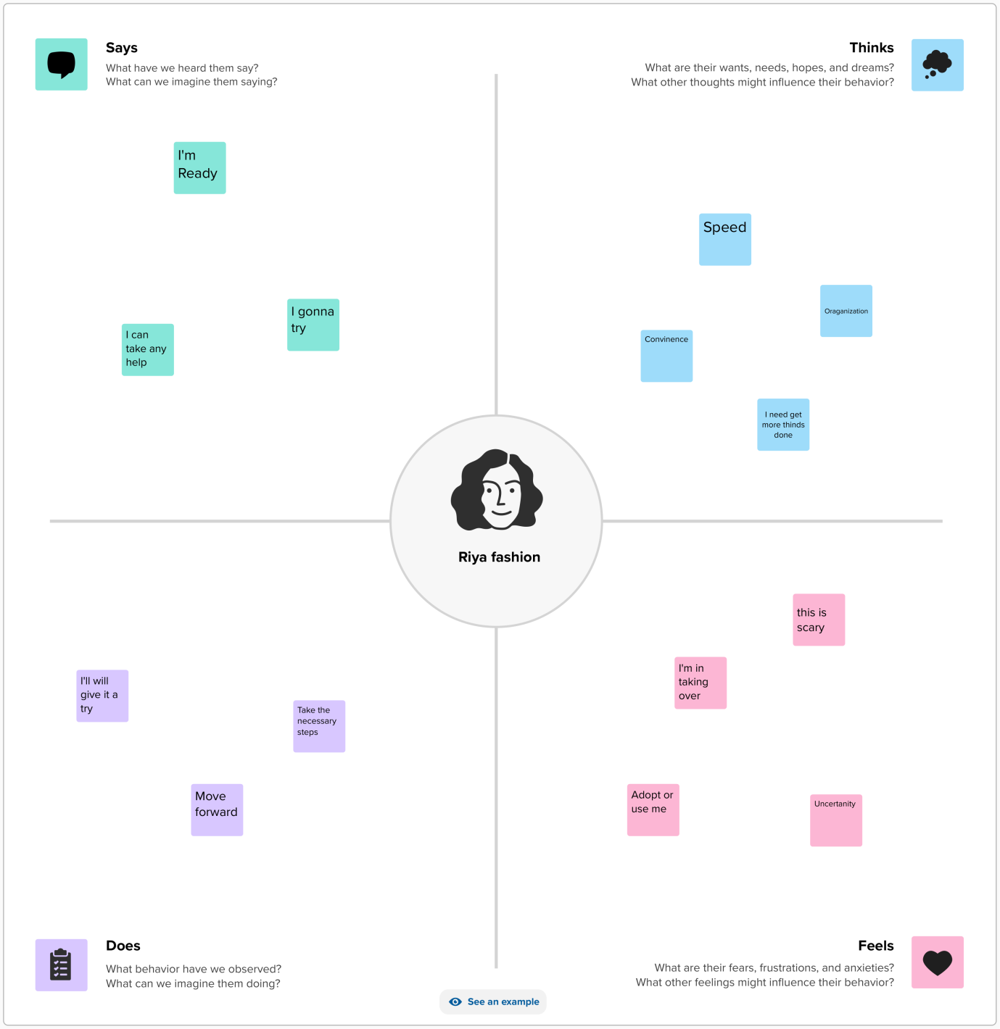

**2.2 Ideation & brainstorming map**

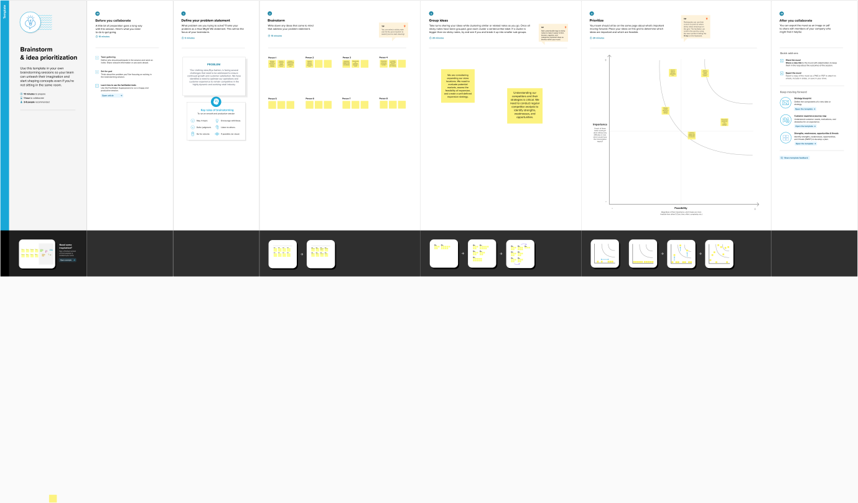

**3.RESULT**

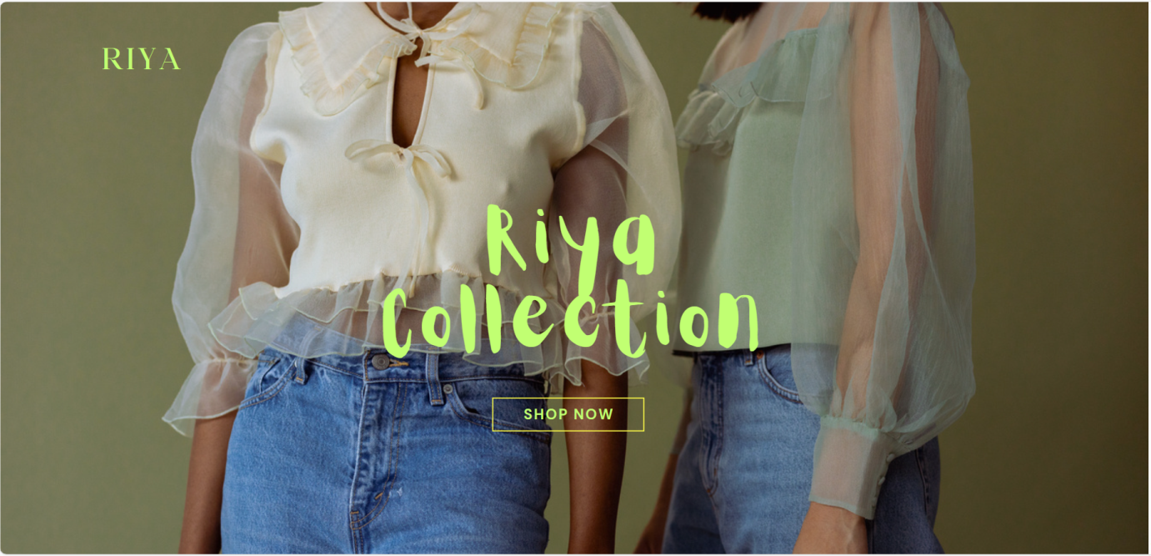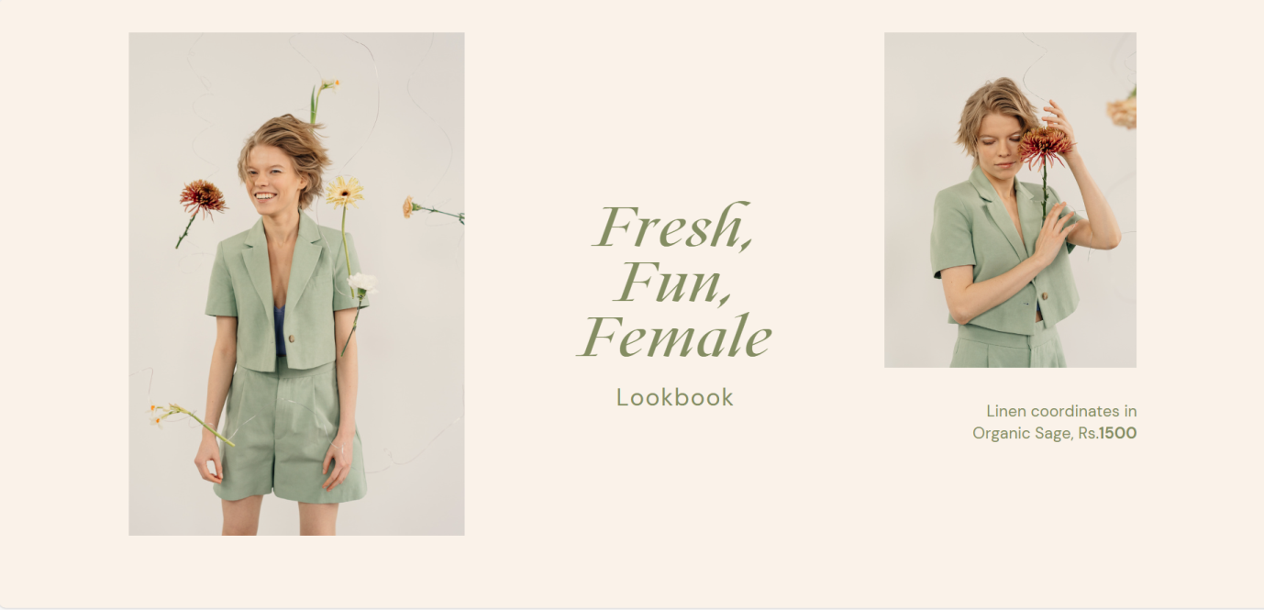

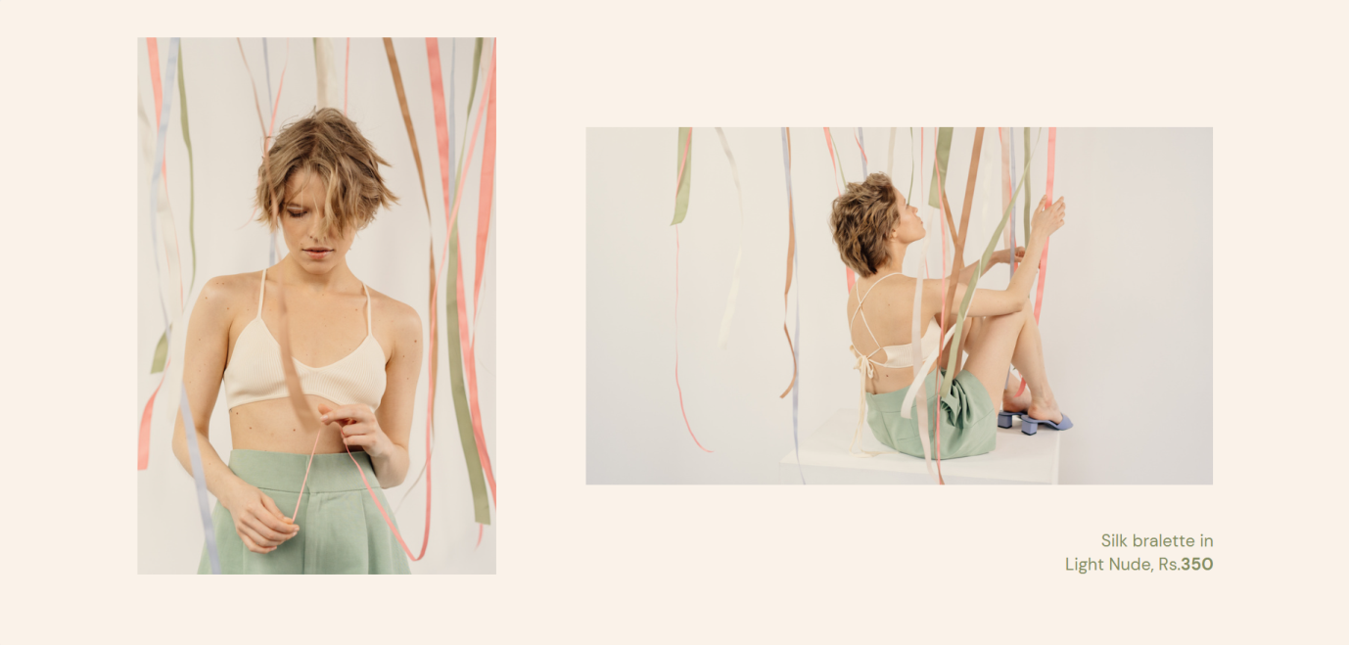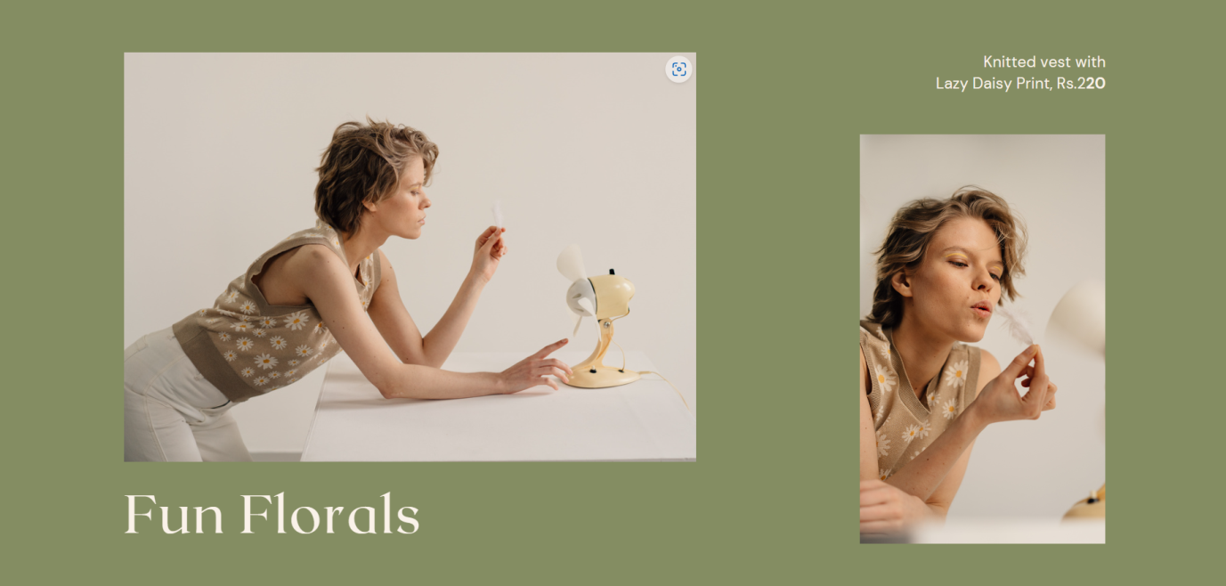

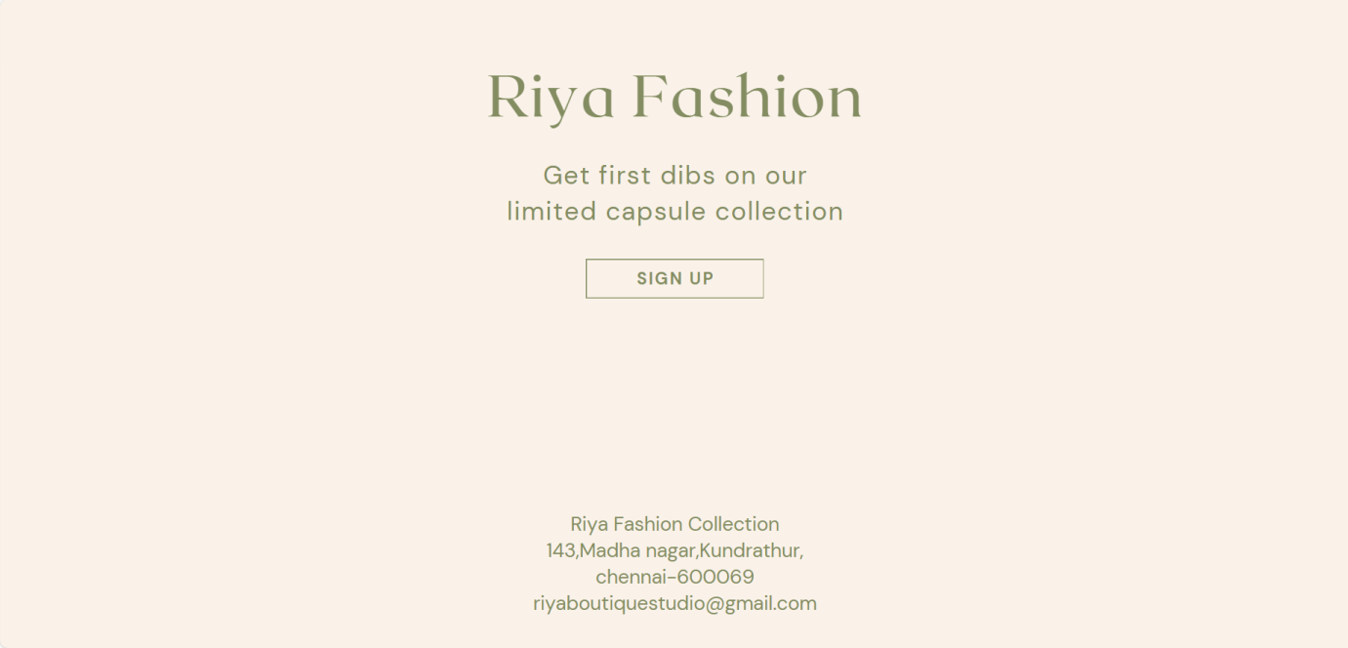

**4.Advantages & Disadvantages**

**Advantage:**

1.selling quality products

2.Door delivery free

3.low cost

**Disadvantage:**

1.Limited products

**5.Applications**

1.Markets

2.Bussiness Retail

3.Industry

4.Textile shops.

**6.Conclusion**

"In conclusion, Riya boutique collection stands at a pivotal juncture in its journey within the dynamic and competitive world of retail fashion. As we've assessed the various challenges and opportunities that lie ahead, it's evident that there is immense potential for growth and improvement.